Taylor Pedretti

005488635

Homework 3

Question 1:

Finger tables are next to the nodes. The node that has 7 within it’s Key values is Node 9, the route taken will be Node 11 to Node 2, then Node 2 to Node 5 and finally Node 5 to Node 9.

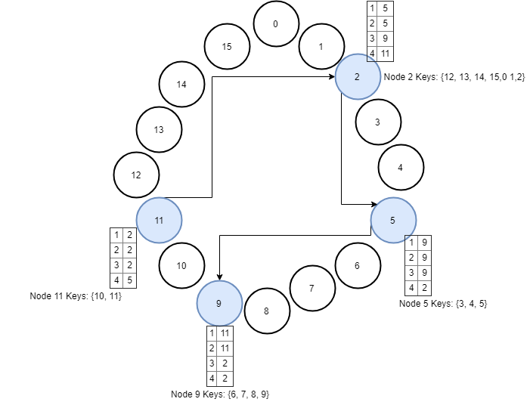

Question 2:

1. Both URLs are location independent because their domains don’t truly tell us their locations are at. “.org” is mainly used for organizations and “.nl” is a top-level domain for the Netherlands, plus both URLs could be hosted on the same server just the URLs are pointed to the same server, or they could be mirrored both hosted else where away from each other.
2. First clock ticks at 1,000 times per milliseconds and the second clock is 990 times per milliseconds so the formula is: $\left(1000-990\right)*1000*60=600,000 time/minute$

Question 3:

1. If a is in Pi and b is in Pj,
   1. Cj(b) = max(Cj(b), tm + d) which tm = Ci(a) or all k,
   2. Cj(b)[k] = max(Cj(b)[k], tm[k]) where tm[k] = Ci(a)
2. So if a, b belong to the same process, value of d does not affect.

Question 4: